Phase 1 – What's hidden inside the bottle?

Main issues
What is the content of the mysterious bottle?
What can we know and what can't we know about the contents of the bottle?
How is a statistical study organized?
How can we collect data to find out the contents of the bottle?
How can we organize and present the collected data?
How can we analyze the data to formulate hypotheses about the contents of the bottle?
How can we validate our hypotheses?
Objectives
- Become familiar with the concept of statistical study.
- Learn to generate hypotheses and collect data systematically.
- Reflect on the importance of sample size and randomness in data collection.
- Introduce the basic vocabulary of statistics (hypothesis, population, sample, ...).

Phase structure: main moments, timing and classroom dynamics

[0] Organizing group work and planning 5 minutes

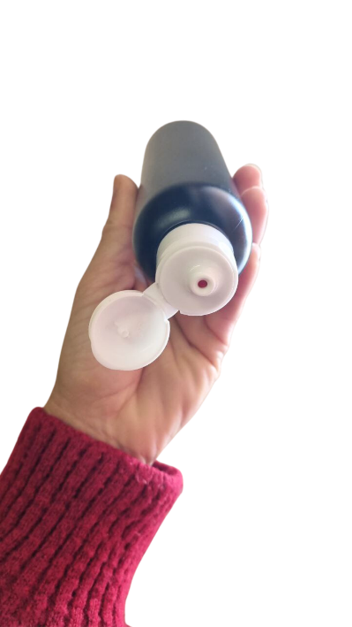
The teacher divides the students into groups and explains the dynamics of the upcoming sessions: “We will study a question during X sessions, you will have to present a work dossier and a final report. The evaluation will be [...]” . If desired, at this point the responsibilities of the different roles within the team can also be discussed.

You can also take the opportunity to introduce this topic related to product quality control and the bottle experiment as a simulation of a quality control process.

[1] Presentació de la qüestió inicial i primeres hipòtesis 20 minutes
The teacher shows a bottle to the class and asks the students what its contents are, making it clear that the bottle cannot be opened, but that one can look through the hole. (Figure 1) The goal is to find out what is inside the bottle.
The teacher then distributes the bottles to the teams ( Figure 2) and presents the objective question: What is the content of the mysterious bottle in front of them? The students explore the bottle and the teacher collects their impressions in a discussion.
Figura 1: Forma de mirar pel forat.

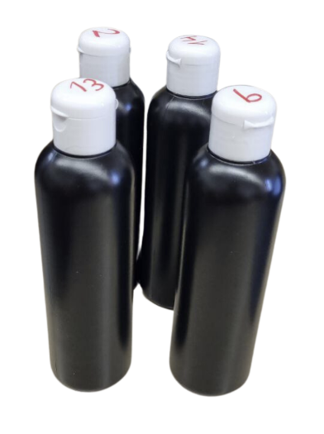
The students explore the bottle and the teacher collects their impressions in a discussion.
- “ The bottle has some kind of small objects in it.”
- "They are bracelet beads, because I looked through the hole in the bottle and saw the little hole in the middle."
- “There are different colors of balls”
- “There are at least 2 green ones, because I saw them at the same time”
- “There are a lot of blue balls, because when I look they always come out blue”
- “Well, I get more roses, maybe the bottles are not the same”
- ...
Figura 2: Ampolles que es reparteixen entre els diferents equips.

The teacher lets them discuss among themselves what they think about these statements, without validating them.

[2] Debat sobre les dades que necessitem 10 minutes
The teacher comments that a systematic experiment needs to be done . He distributes the dossier [ Phase 1 - Report 1 ], where the students will have to write the bottle number, the date and the role of the members on the first page of report 1.
The teacher asks them to fill in the table: What can we know?/What can we not know? Considering that we will be doing an experiment. Take a moment to fill in the table and share the answers on the board . We hope that the ideas that may come up are:
What can we know?
- The colors that are there.
- If there are colors that appear more than others
What we can't know? The exact number of balls of each color.
Then lead the discussion to ask what we need to know (the total number of balls). The teacher asks what they would do to find out the total number of balls. One option would be to weigh it with an accurate digital scale... we ask the manufacturer... but since we don't have time, we give it as information.
The teacher provides the new information (total number of balls in each bottle) and reflects on whether it is now possible to find out the composition of the bottle , understood as the number of balls of each color inside.
The teacher can also show a random set of pieces, so that students can see that all pieces are the same size and possible colors.

[3] Primeres hipòtesis sobre el contingut de l’ampolla 20 minutes

During the remainder of the 1st session, the teacher will indicate that the students have 20-25 minutes to generate a first hypothesis about the composition of the bottle and fill out the second page of the dossier [ Phase 1 -Report 1 ]. He will let the students develop their own data collection strategies and will walk around the class asking the teams questions about how they organize the collection.

We can expect that some teams will just look through the hole and say what they see, without recording it , or perhaps some will choose inefficient ways to collect it. The teacher will have to look for the teams that develop the best strategies, to use as an example in the subsequent sharing.

[4] Posada en comú de les hipòtesis grupals 10 minutes

The teacher will guide a discussion where we hope hypotheses like these will emerge:

- We believe that there are more blue balls than other colors, because out of the 25 times we looked, 13 times we got a blue ball.

- We believe there are 4 colors, because we have seen at least one ball of each color.

We expect students to select a sample of 25 visualizations, due to similarity to the total balls in the bottle, but it is important for the teacher to reflect that if we look 25 times, some balls may be repeated and therefore, it will not give us an exact reflection of their content. However, this case (making 25 visualizations) is the simplest case since the results can be interpreted directly as the composition of the bottle.

It is also important to remember that to ensure the randomness of the sample collected, the bottle must be mixed well and all data must be collected properly.

We can expect students to propose painting the balls that have come out with a marker, but the teacher should rule out this strategy since the collection cannot be manipulated and we want to reproduce a non-deterministic experiment.

At this time, the teacher must be aware of the natural vocabulary used by the students and emphasize the need to seek common terminology.

[5] Introducció de la terminologia comuna Optional, to work in the classroom or at home
With the aim of introducing students to the topic of statistical studies, the question Q _{2 is proposed} : How is a (statistical) study organized?
The teacher asks the students to try to fill in the information in the table [Phase 1 – Report] with what they think means some actions related to statistical studies.
If you decide to work in the classroom, the teacher can give them a few minutes to talk and write on the board the definitions or specific examples related to the bottles. After a few minutes, the teacher explains. Explanations such as the following can be used:
Generating hypotheses: This is making an assumption about something we want to study. For example, if we want to know if students get enough sleep, a hypothesis could be: "Students who go to bed early perform better in class."
Determine the population: This is identifying the total set of elements or people that we want to study. For example, if we are investigating the reading habits of students at a school, the population would be all the students at the school.
Defining the sample: It is choosing a smaller group that we choose from a population to study. For example, if we want to know how many students play sports in a very large high school, we can ask just one class instead of the entire high school.
Choosing the sample size: This is choosing the amount of data we will collect about the sample. It is the number of elements that the sample includes.
Collect data: This is obtaining information to check if our hypothesis is correct. We can do this through surveys, observations or experiments.
Organize the data: Once we have the data, we need to put it in order so that it is easier to understand. For example, we can make a table with the results or group the data into categories.
Presenting data: This is showing information in a way that is clear and understandable to others. We can use graphs, tables, or summaries to make it easier to understand. For example, if we have done a survey about the favorite sports of the class, we can make a bar chart to see which is the most popular.
Analyzing data: It is examining the information we have collected to see if there are patterns or relationships. We can use graphs or calculations to better understand what the data is telling us.
Interpreting the data: This is explaining what the results of the analysis mean. This helps us answer the initial question and see if the hypothesis we had made was correct or not.
Validate the hypothesis: It is checking whether our hypothesis is true or not, based on the data collected. If the data confirms what we thought, we say that the hypothesis is correct. If not, we will have to change it or look for a different explanation. For example, if we wanted to know if sleeping more helps to get better grades and the data shows that this is not always the case, we will have to review our hypothesis.
Determine the confidence level: Estimate a percentage that represents how confident we are that the results of a study correctly represent reality. For example, if we say that a study has a confidence level of 100%, it means that we are completely confident in our hypothesis, and if it is 0%, it means that it is definitely incorrect.
The teacher should emphasize that when they have to write their reports, students should underline (preferably with colors) the action they are talking about. In this way, we give weight and importance not only to concepts (data, sample, degree of confidence,...) but also processes (generating hypotheses, collecting data, validating hypotheses,...).

Resources and materials needed/available
Different bottles : Decide on a color configuration and number of bottles. The decision on the initial configuration will depend on the group. For example, in the case of 4th grade, the whole group worked with the same bottle and there were only 2 colors: 4 yellow balls and 1 green. For 1st grade, we can recommend:
Number of different bottles: 2
Total number of balls: 25
Number of colors: 4
Color settings:
Bottle A: 12 Blue, 7 Red, 5 Yellow and 1 Pink
Bottle B: 1 Blue, 8 Red, 2 Yellow and 14 Pink

The bottles will be numbered to keep track of which team is studying which bottle.
We recommend that, once the bottles are assembled, the cap is glued with silicone so that it is (almost) impossible to open them.

The Phase 1 report - Report
Class board : Where the teacher will have to write the barrage of questions and, if they consider it, the new information added.

Relevant comments for Phase management
- Make sure that we control which group we distribute each bottle to, so that in the following sessions we can distribute the same bottles.
Resisting...
- Give students lots of guidance on how to collect data. We will let them explore different ways and then share them.

